**PROGRAMME**

**CLASSICAL GUITAR RECITAL BY NICOLAS W MORROW BROWN**

**Given at St Mary’s Church, Shipton Sollars**

**On 31st August 2024 at 2:30 pm**

**Alonso de Mudarra (1510-1580)**

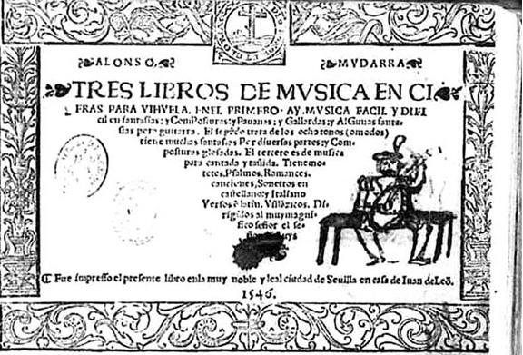

*Romanesca sobre Guardame las Vacas*

*Fantasia X, ‘imitating the harp in the manner of Ludovico’*

Alonso de Mudarra was a Spanish composer of the Renaissance, and played the vihuela, a guitar-shaped string instrument. He was the composer of the earliest surviving music for the vihuela and the four-course guitar, contained in the collection *Tres libros de musica en cifras para-Vihuela* published in Seville in 1546. Mudarra was Canon of Seville Cathedral until his death in 1580 when his considerable fortune was distributed to the poor of the city in accordance with his will.

**George Frederick Handel (1685 -1759)**

*Sarabande & Variations from Suite No 11 for harpsichord HWV(arr Kanengiser)*

*Minuets I & II: from Aylesford Pieces (arr Segovia)*

1The Sarabande and variations is based on the popular baroque refrain *Folies D’Espagne,* or *La Folia*. The 'Aylesford Collection' is a grouping of harpsichord pieces named after the 3rd Earl of Aylesford; it was originally assembled by Handel's librettist, Charles Jennens, (the author of *Messiah*), and subsequently bequeathed to Jennens' cousin, the Earl, in 1773. The pieces were first published by Schott in 1928; they were transcribed for the guitar by Andres Segovia in the 1930s.

**Johann Sebastian Bach (1685-1750)**

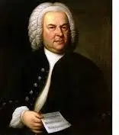

*Loure*, *Gavotte en Rondeau*, *Bouree* and *Gigue* from Suite No 4 in E major *BWV 1006a (arr Koonce)*

Bach’s Violin Partita in E major, from which this Suite is adapted, is one of his most genial and witty compositions. There is a keyboard transcription from the 1740s, although not in Bach’s hand. As the key of E major is unplayable on the baroque lute, this ‘Lute Suite’ is unlikely to have been written or even adapted for that instrument by Bach, but the Suite has nevertheless held a place in the guitar repertoire for many decades.

(See the article by Clive Titmuss: *The Myth of Bach’s Lute Suites,*available online, which also contains an entertaining fictional account of a meeting between Bach and the lutenist Sylvius Leopold Weiss.

**Fernando Sor (1778-1839)**

*Three Etudes for Guitar: Op. 35, No 17 in D; Op 6, No 12 in A; Op 6, No 11 in E minor*

Fernando Sor was a Spanish classical guitarist and composer of the late Classical and early Romantic era. Best known for his solo classical guitar music, he also composed an opera, a ballet, and instrumental and orchestral works. Despite his Iberian origin, his music is in the style of the Viennese classics.

Sor was a virtuoso exponent of the guitar. His Studies Op. 6, Op. 29, Op. 31, and Op. 35 have been widely played for two hundred years and are regularly reprinted. They are full of melody and invention.

Sor’s guitar was smaller than the modern instrument, resulting in some of his more advanced pieces being a little demanding to play.

**Heitor Villa-Lobos (1887-1959)**

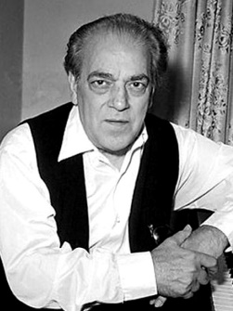

*Mazurka-Choro*

*Gavota-Choro*

*Schottisch-Choro*

From the *Suite Populaire Bresilienne*

Villa-Lobos was primarily a cellist, but in later years taught himself the guitar. The word *chôro* comes from the Portuguese term *chorar*, which means "to cry" or "to complain". In his early days, Villa-Lobos would perform and improvise with other ‘*chorões’* in cafés, nightclubs, and cinemas in order to make his living. This enabled him to compose many pieces inspired by the musical style and folk material of chorões, entitled chôros, a blend of Brazilian folk music with European dances with a generally steady tempo and a certain sentimental and melancholic tone.

**Joaquin Malats (1872-1912)**

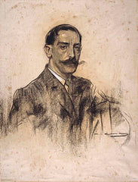

*Serenata Espanola*

Malats was a Catalan composer and pianist from Barcelona. After performing throughout Europe and the United States with extraordinary success. he studied at the Paris Conservatoire, where he won first prize in piano in 1903. The *Serenata* for piano is now very much part of the classical guitar repertoire.

**Antonio Ruiz-Pipo (1934-1997)**

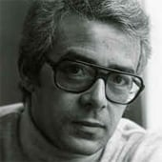

*Cancion y Danza* No 1

Antonio Ruiz-Pipó studied the piano with Alicia de Larrocha. In his youth he played the guitar a little, and this provided him with a working knowledge of the instrument, for which he wrote numerous works; the very approachable *Cancion y Danza*is his main legacy for the guitar, the *Danza* requiring an unusual technique in the right hand. His music is not consistently tonal. His treatment and harmonization of his thematic material (often deceptively simple sounding) is sophisticated, and he revelled in sharp contrasts of mood and colour. He died in Paris, aged 63.

**Information about the performer**

Nicolas began playing the classical guitar in his late teens, inspired by the artistry of Julian Bream. He has given and taken part in many concerts, including as a guitar duo with Raymond Burley and with the harpsichordist Richard Lester. He has played in masterclasses with David Russell, Scott Tennant and Nigel North among others. He is an occasional student with Craig Ogden, Director of Guitar, the Royal Northern College of Music, and has a long association with Professor Carlos Bonell of the Royal College of Music.

In 2013, at the age of 66, Nicolas was appointed a Licentiate of Trinity College London, with Distinction, for his recital of music by J S Bach, Mauro Guiliani, Agustin Barrios and Richard Rodney Bennett. In 2007 his self-produced CD *Guitar Classics*became available, featuring music by Bach, Scarlatti, Llobet and Turina.

Since retirement from his legal career in 2022 Nicolas has been able to devote more time to playing, exploring new repertoire and performing on the guitar.