Cultural Assets Fund

Urgent conservation repairs
Westgate Chapel, Upper Weardale, Co. Durham, DL13 1LQ

Expression of Interest Form

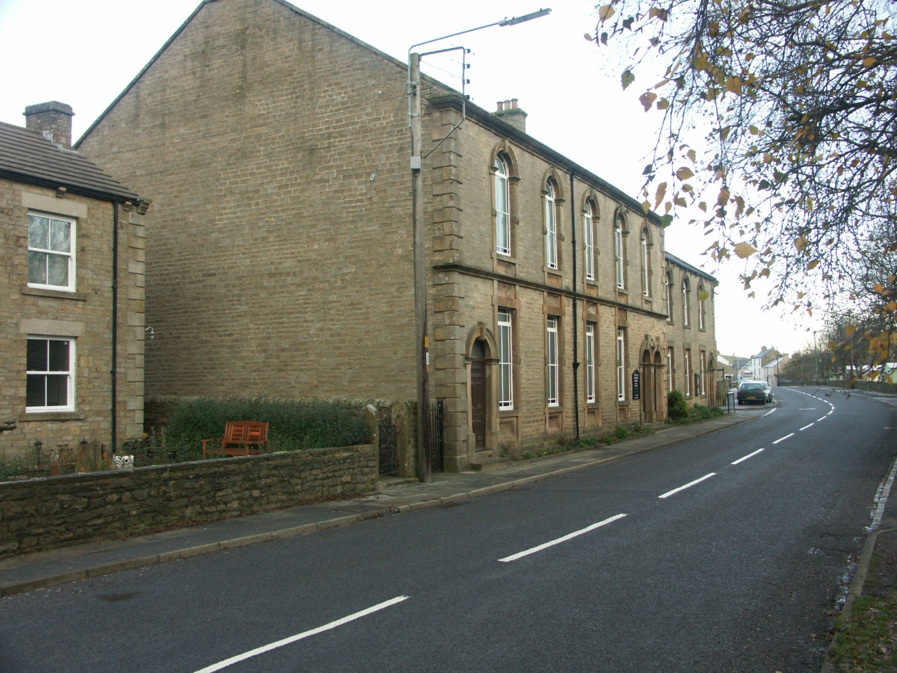

We thank you for your interest in the urgent conservation repairs at Westgate Chapel. Please complete the form below and submit by email to Kathryn Moore kathrynmoore@thecct.org.uk by noon on 31st May 2024.

We expect to issue the pre-qualification questionnaire to interested parties on or shortly after 03/06/2024.

Trading Name of the Organisation submitting this Application Form:
Click or tap here to enter text.
Contact name for enquiries about this contract:
Click or tap here to enter text.
Contact position (Job Title):
Click or tap here to enter text.
Address:
Click or tap here to enter text.
Postcode:
Click or tap here to enter text.
Telephone Number(s):
Click or tap here to enter text.
Click or tap here to enter text.
E-mail addresses:
Click or tap here to enter text.
Click or tap here to enter text.
Website address (if applicable):
Click or tap here to enter text.
Registered Name of Organisation submitting this application (if different from the above):
Click or tap here to enter text.
Registered Address (if different from the above):
Click or tap here to enter text.

Postcode (if different from the above):
Click or tap here to enter text.
It is a requirement that the main contractor for the project is Construction Industry Scheme registered and that the urgent works programme is complete by the end of December 2024.
Is your organisation Construction Industry Scheme registered? | Choose an item.
Will you have capacity to complete a c. 4 month programme of site works by the end of December 2024. | Choose an item.

